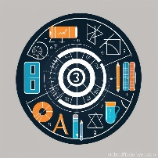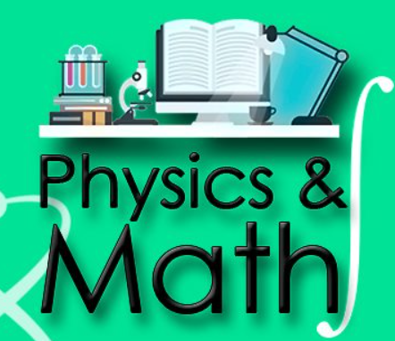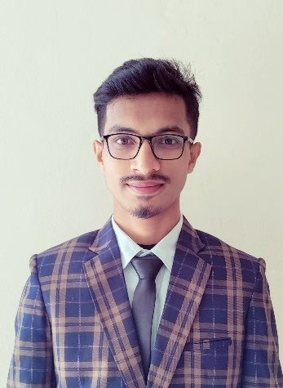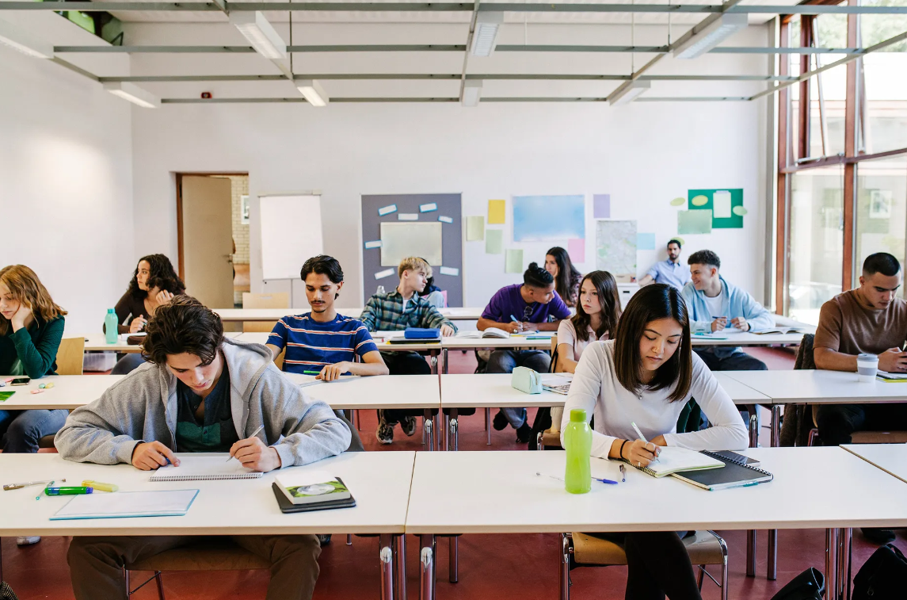

**MD IMAM HOSSEN**

**DEPT. OF PHYSICS**

**UNIVERSITY OF BARISHAL**

**SUBJECT:**

***PHYSICS,* *HIGHERMATH & ICT***

**HSC**

**ACADEMIC &**

**ADDMISSION COURSE**

**EDUCATION IS POWER**

**HOME TUTOR SERVICE**

**MOBILE NO: 01827627566**

**CONTACT**